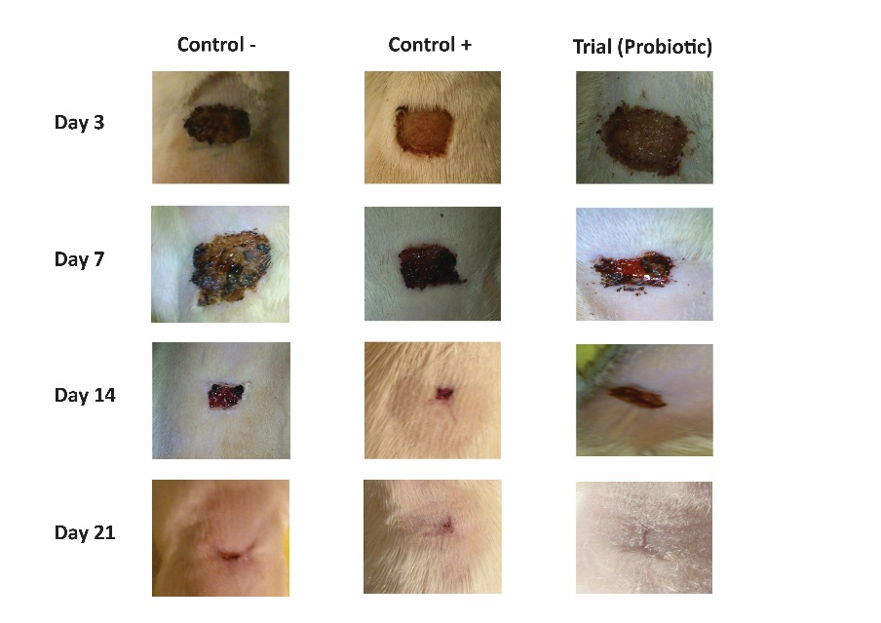

Supplementary figure 1. The progress of wound healing among all experimental groups

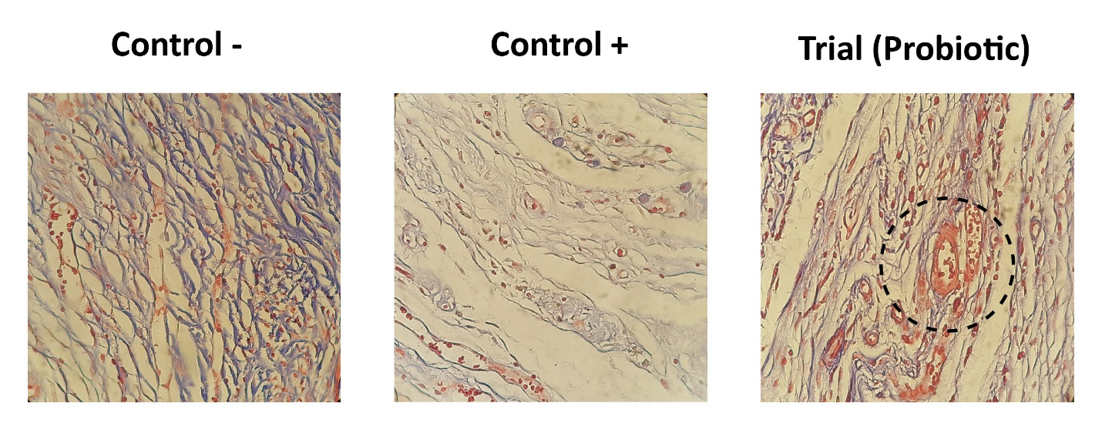

Supplementary figure 2. The evaluation of angiogenesis. The microscopic analysis indicated that L. paracasei TD3 could induce angiogenesis in Trial group

