Supplementary Table 1. Real Time mixture

|  |  |  |
| --- | --- | --- |
| No. | Reagent | Volume |
| 1 | cDNA | 1 µl |
| 2 | Sybr Green qPCR Mix, 2X | 10.4 µl |
| 3 | Primer forward | 0.5 µl |
| 4 | Primer reverse | 0.5 µl |
| 5 | H2O PCR grade | 7.6 µl |
| 6 | Total volume | 20 µl |

Supplementary Table 2. Real Time program

|  |  |  |  |  |
| --- | --- | --- | --- | --- |
| No. | Real Time step | Temperature (°C) | Duration | Cycle |
| 1 | Initial activation | 95 | 3 min | 1 |
| 2 | Cycles of denaturation | 95 | 20 sec |
| 3 | Annealing and extension | 60, 58 | 20 sec |
| 4 | Elongation | 72 | 1 sec | 45 |

Supplementary Table 3. Primer sequences of studied genes and the internal control gene

|  |  |  |  |
| --- | --- | --- | --- |
| Gene name | Primer name | Primer sequence | Product size |
| GAPDH | GAPDH (F) | CCACTCCTCCACCTTTGACGCT | 139 |
| GAPDH (R) | TTACTCCTTGGAGGCCATGTGGG |
| Caspase 3 | Caspase 3 (F) | TCCTTTTCCTTTGACGCTACTT | 111 |
| Caspase 3 (R) | AACCACCAACCAACCATTTC |
| P21 | P21 (F) | TTGTACCCTTGTGCCTCGCTCA | 128 |
| P21 (R) | AGATCAGCCGGCGTTTGGAGT |
| P53 | P53 (F) | CCACCATCCACTACAACTAC | 135 |
| P53 (R) | AAACACGCACCTCAAAGC |

**B**

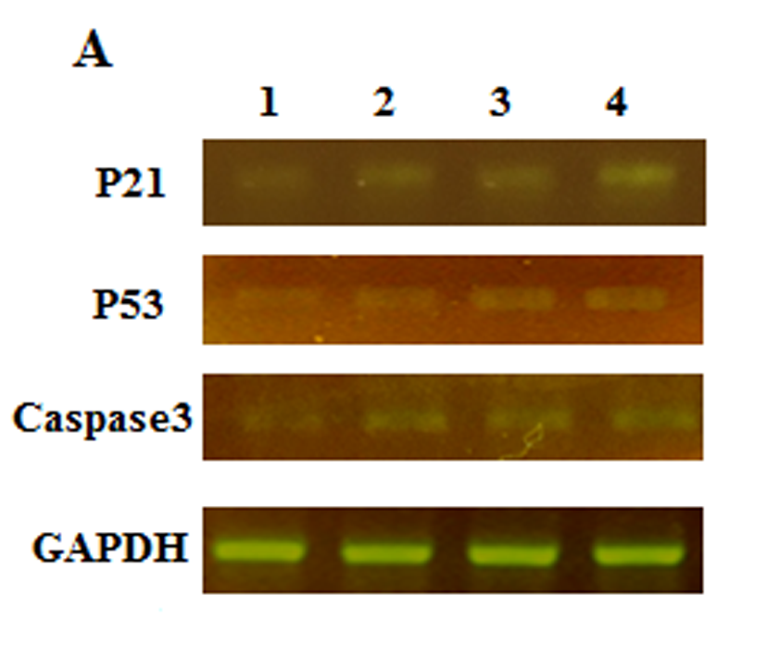

Supplementary Figure 1. Gene expression control groups and co-culture. A: Total RNA isolation and cDNA was synthesized, samples were compared with based on the expression of GAPDH gene. PCR products were electrophoresis in 2 % agarose gel to analyze the expression of genes of P21, P53, Caspase3 and GAPDH, Lane 1: cell line HT29, Lane 2: AM-MSC, Lanes 3 and 4: co-culture (HT29 with AM-MSC), P21, P53 and Caspase-3 were expressed in co-culture treatment groups compared with cell line HT29. B: to evaluate gene expression of p21, P53 and caspase3 Real Time-PCR assay were used, P21, P53 and caspase3 were significantly highly expressed co-culture groups compared with control cell line HT29.