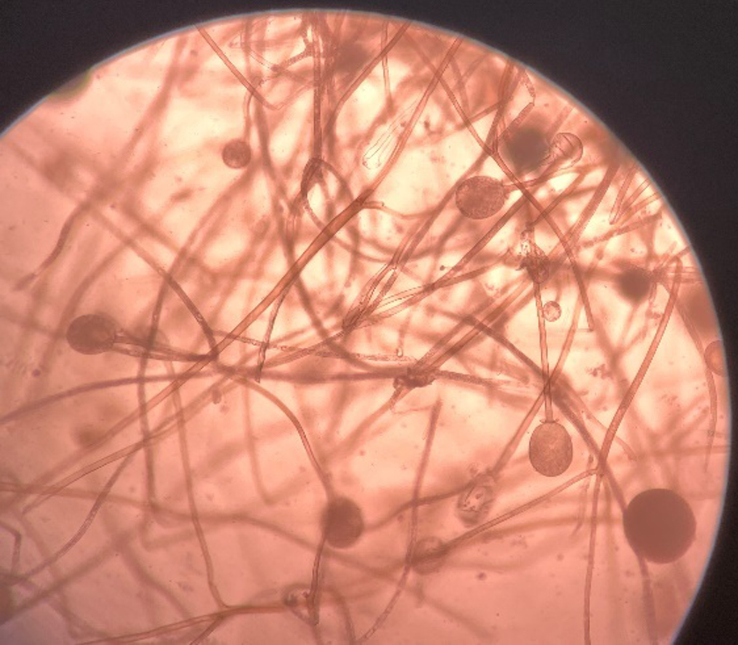

Supplementary figure 2. KOH mount showing broad aseptate hyphae of Mucorales with fruiting bodies

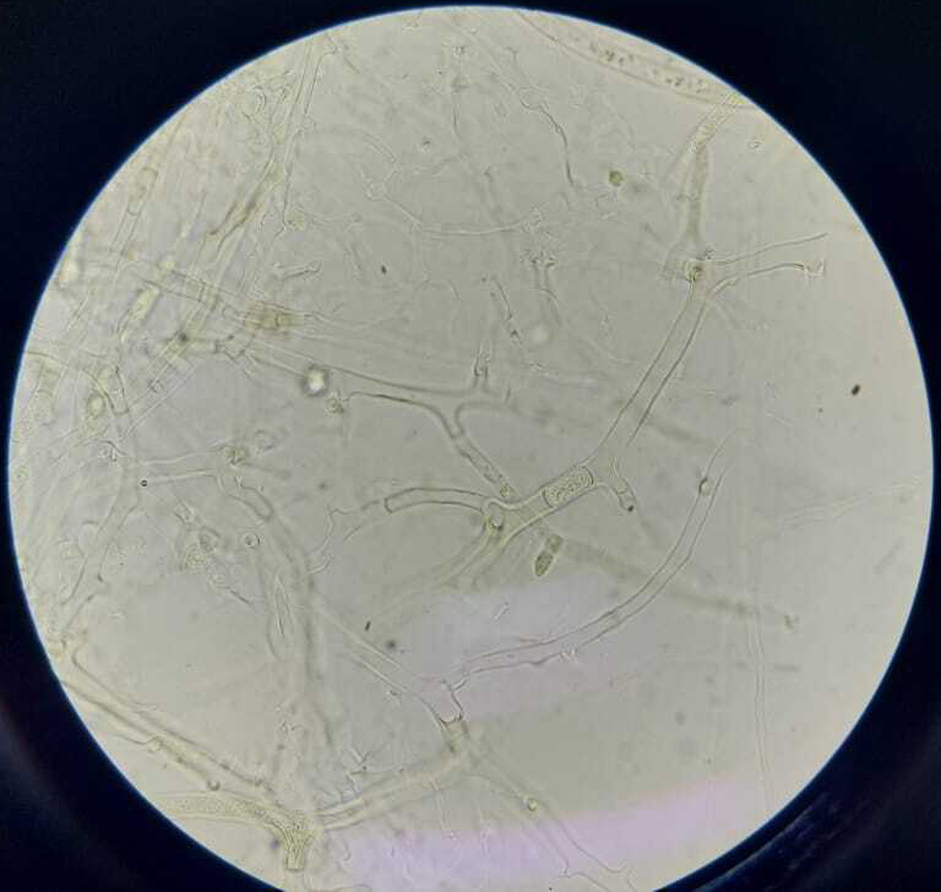

Supplementary figure 1. KOH mount showing broad aseptate hyphae with wide angle branching

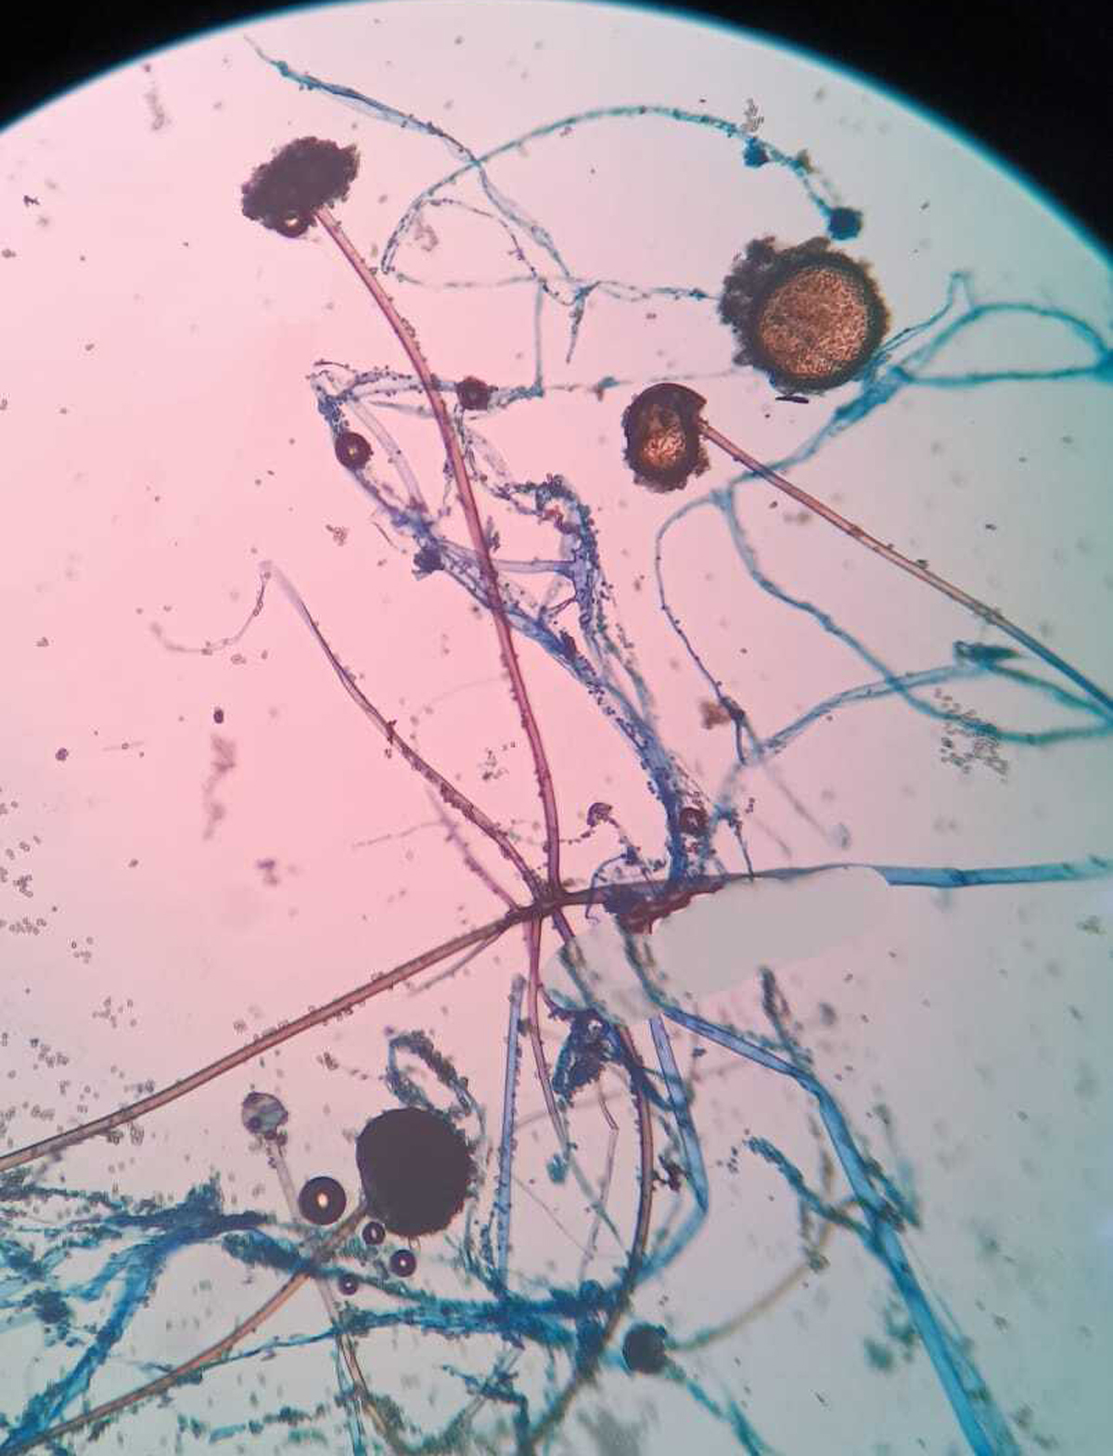

Supplementary figure 4. Lactophenol Cotton Blue (LPCB) mount showing *Syncephalastrum racemosum*

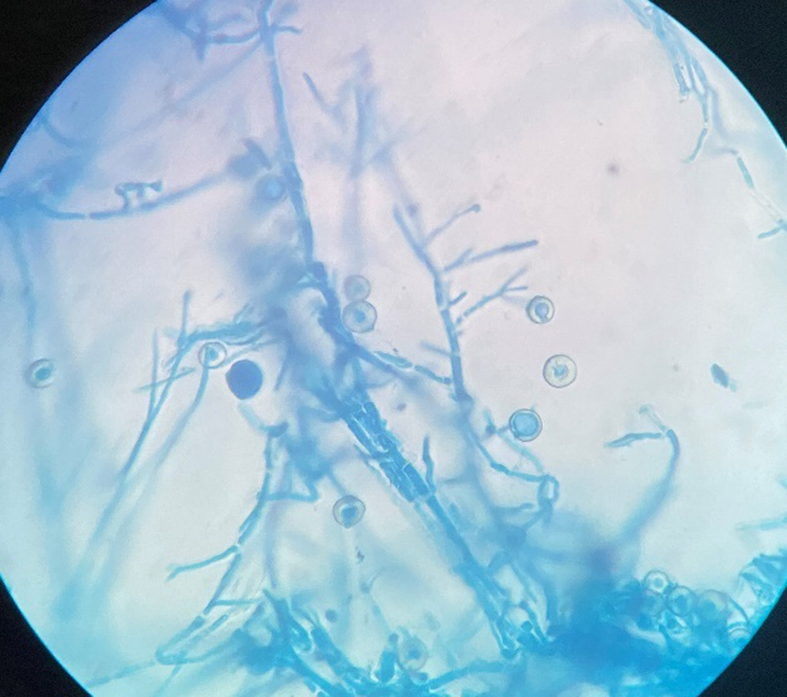

Supplementary figure 3. Lactophenol Cotton Blue (LPCB) mount showing Hülle cells of *Aspergillus nidulans*