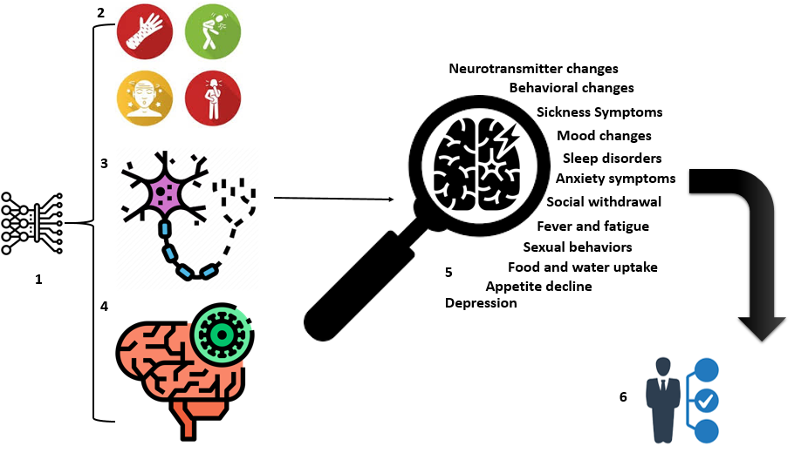

**Figure 1.** **Conceptual application of ML in linking common complaints between microbial toxin’s profile and brain neural network disorders**. 1) ML models will develop for analyzing classified and categorized different libraries of patients disease information include for example: 2) COVID-19 symptoms and lab data, Sepsis and endotoxemia markers, Hospital-acquired infections criteria, Surgical site infections (SSI) and other postoperative infections indexes, Microbiological test results, Musculoskeletal infections symptoms, Types of antimicrobial prescription and microbial resistance, monitoring and tracking of site-specific infections, 3, 4) Neurodegeneration markers monitoring by analyzing Neuroimaging informations, cognitive performance tests, different omics data like transcriptomic or genomic data, biomarker data, motor performance test and metabolomics data, 5) Finding explanations based on analysis predictions and results and finally 6) Held best human decision.